Bài thực hành 7

Trần Văn Quyền

MSSV: 19574802010166

Câu 1:

import cv2

import matplotlib.pyplot as plt

img = cv2.imread("D:\\Tran Quyen\\quyen.jpg")

x1 = int(input("Nhap toa do x1: "))

y1 = int(input("Nhap toa do y1: "))

x2 = int(input("Nhap toa do x2: "))

y2 = int(input("Nhap toa do y2: "))

anh_cat = img[y1:y2, x1:x2]

anh_xam = cv2.cvtColor(anh_cat, cv2.COLOR_BGR2GRAY)

anh_thichnghi = cv2.adaptiveThreshold(anh_xam, 255, cv2.ADAPTIVE_THRESH_MEAN_C, cv2.THRESH_BINARY, 11, 2)

anh_canny = cv2.Canny(anh_xam, 100, 200)

plt.subplot(2,2,1), plt.imshow(anh_cat, cmap='gray'), plt.title("Binh thuong"), plt.axis('off')

plt.subplot(2,2,2), plt.imshow(anh_xam, cmap='gray'), plt.title("Anh xam"), plt.axis('off')

plt.subplot(2,2,3), plt.imshow(anh_thichnghi, cmap='gray'), plt.title("Thich nghi"), plt.axis('off')

plt.subplot(2,2,4), plt.imshow(anh_canny, cmap='gray'), plt.title("Tach bien"), plt.axis('off')

plt.show()

cv2.waitKey(0)

cv2.destroyAllWindows()

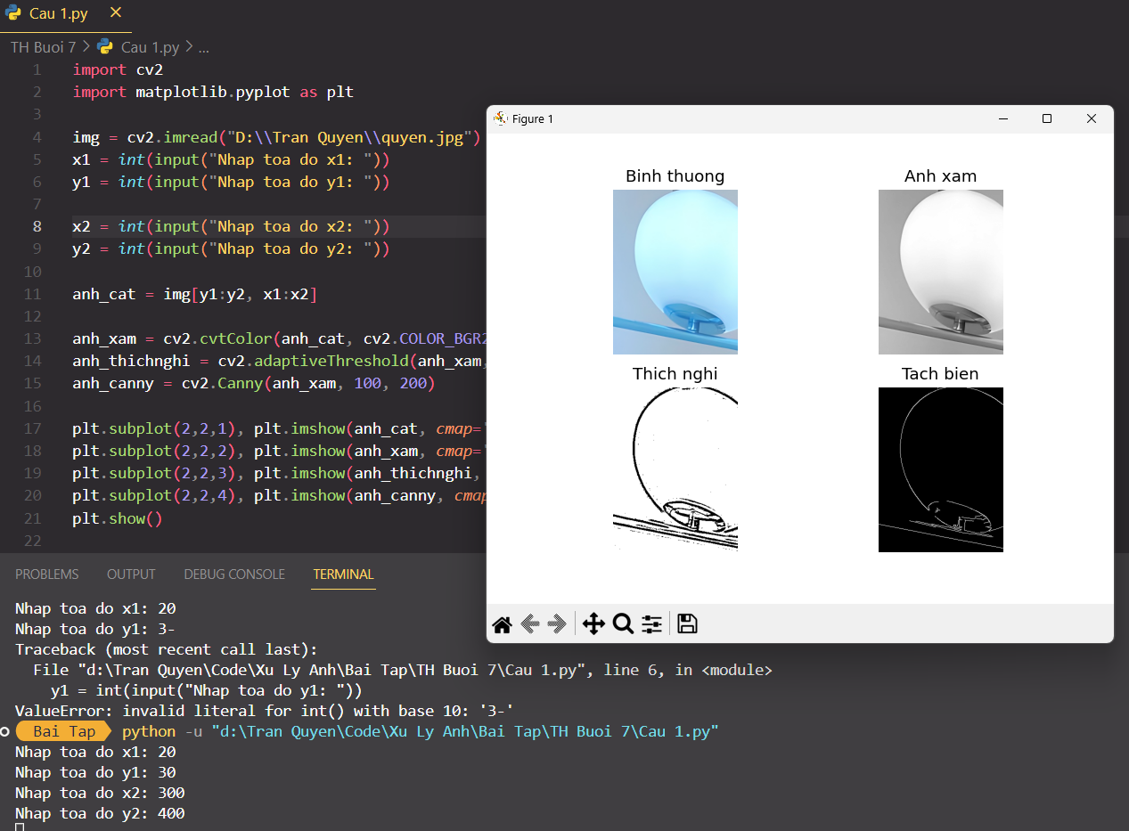

Câu 2:

import cv2

image = cv2.imread('D:\\Tran Quyen\\quyen.jpg')

img = cv2.resize(image, (300,400))

(rows, cols) = img.shape[:2]

alpha = 0

def set_alpha(pos):

global alpha

alpha = pos

cv2.namedWindow('show')

cv2.resizeWindow('show', 500, 100)

cv2.createTrackbar('goc quay','show',0,360, set_alpha)

while True:

M = cv2.getRotationMatrix2D(center = (cols/2,rows/2), angle=alpha, scale=1)

ro = cv2.warpAffine(img, M, (cols, rows))

cv2.imshow('show',ro)

if cv2.waitKey(10) == ord('q'):

break

cv2.destroyAllWindows()

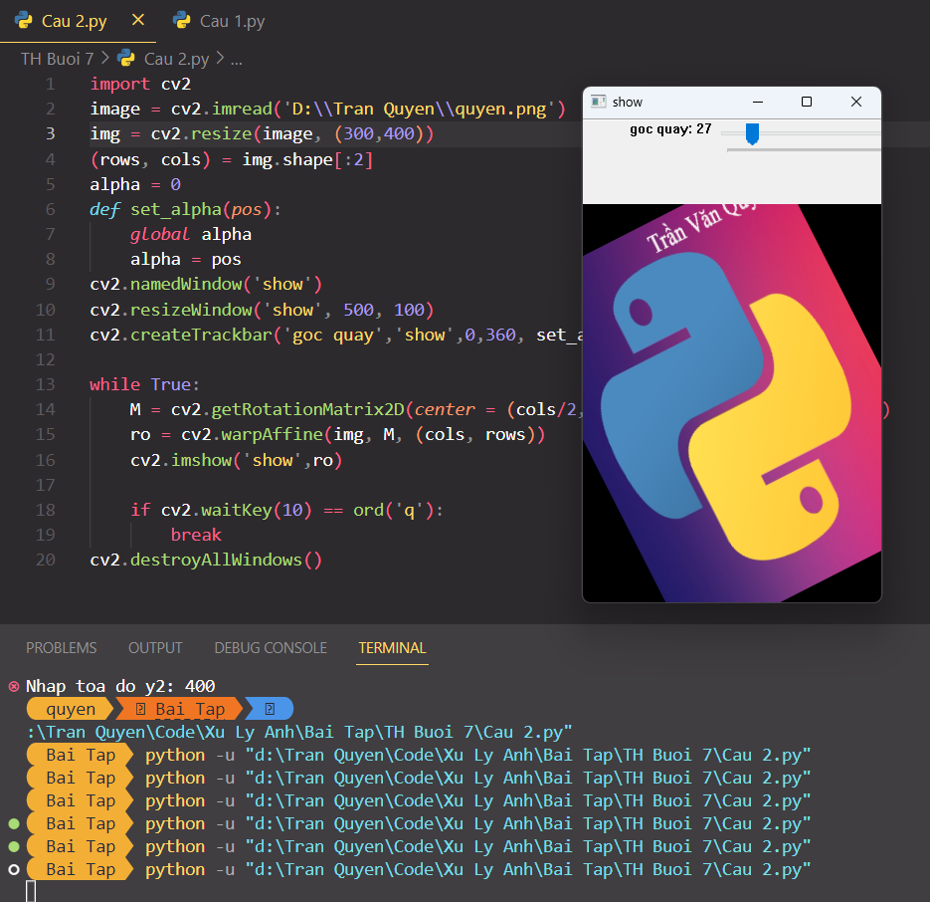

Câu 3:

import cv2

img = cv2.imread("D:\\Tran Quyen\\quyen.png")

kenel = 3

def get_kenel(x):

global kenel

kenel = x

cv2.namedWindow("Bo loc trung binh")

cv2.createTrackbar("Kenel","Bo loc trung binh",0,100,get_kenel)

while True:

trung_binh = cv2.blur(img, (kenel, kenel))

cv2.imshow("Bo loc trung binh", trung_binh)

if cv2.waitKey(1) == ord('s'):

break

if cv2.waitKey(1) == ord('q'):

cv2.imwrite("D:\\Tran Quyen\\trung binh.png",trung_binh)

cv2.destroyAllWindows()

